Page under active construction

Community software & services

Native C64 applications
Native C64 applications that run directly on the Commodore 64.

C64UHEX
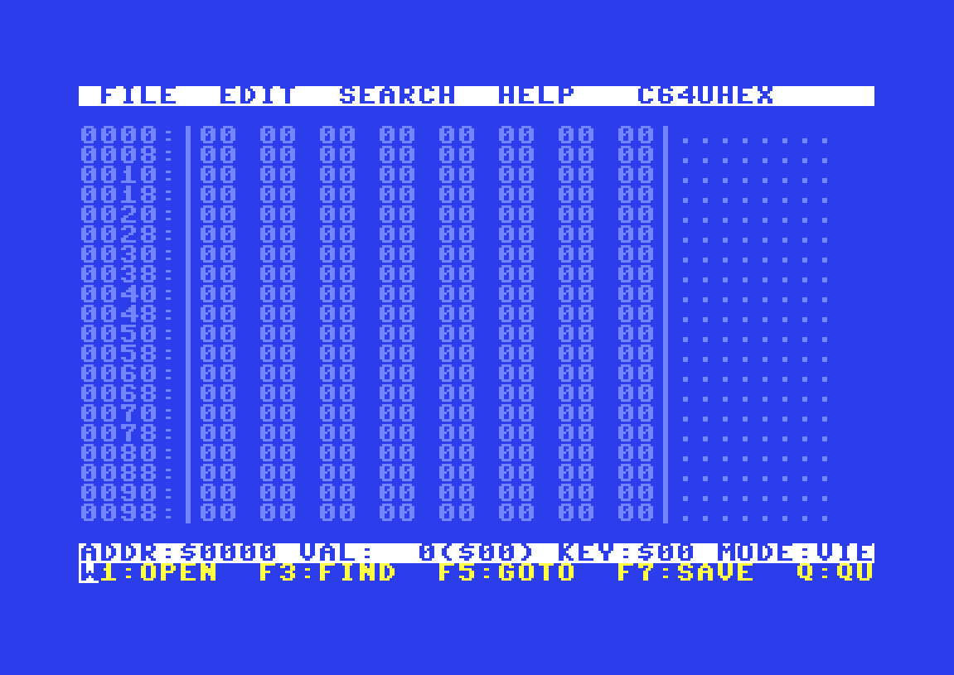
under active development
C64UHEX is a native hex editor for the Commodore 64. It provides professional, byte-level inspection and modification of binary data using a true PETSCII interface, respecting the constraints and character semantics of the original platform.
- Project page
  - https://github.com/drericflores/c64uhex

AdvEditC64 - Advanced Commodore Editor
under active development
Advanced Commodore Editor is a native, full-screen text editor designed specifically for the Commodore 64, with special attention given to the C64 Ultimate and its USB-based storage workflow.
The editor is inspired by the philosophy of the Linux nano editor: Simple controls, fast interaction, minimal cognitive overhead, and clear on-screen prompts while respecting the technical constraints and historical behavior of vintage hardware.
- Project page
  - https://github.com/drericflores/AdveditC64

Ultimate64-sid-player
under active development
Plays SID songs from a directory on your C64.
Run sid_finder.prg on your C64, in the directory where your SID files are, or specify the path. Enable Web Remote service, configure the config file, then run the python script to have it play the songs in the directory. (See github for more details)
The difference between this and remote sid playing through the web manager for C64U is this can play multiple files without interaction, random and loop, like a playlist.
Known limitations/possible bugs:
1. Filename length, if it cannot read .SID the file might not get detected.
2. Max number of files not tested, only tested with 7 SID files.
Disable Web Remote service when you turn off your C64U, it might corrupt Flash memory.
This is a ALPHA release (31th of December 2025)
- Project
  - https://github.com/nesfrk81/ultimate64-sid-player

Remote control applications
Remote control applications that enable viewing, playing, copying, and otherwise interacting with a system from another computer.

Ultimate 64 Web Music Player
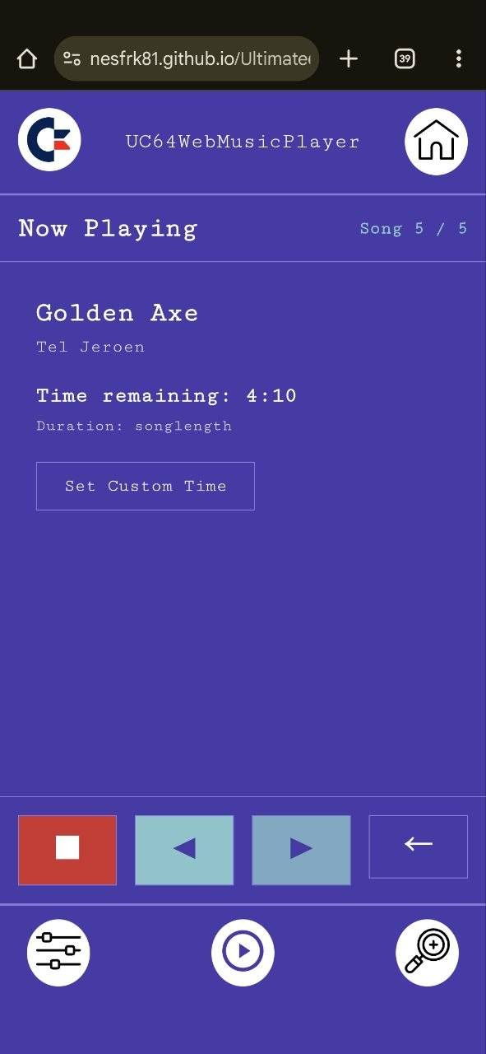
under active development
Use any device at your home with a web browser, to play your favorite SID songs. Designed to be used with your mobile phone to have a easy way to control the music that is coming out of your C64. Once the proxy is running, you can use the player URL to access the application. For easier mobile/tablet usage.
Go to the project page for instructions on how to get it running, if you run it as a Progressive Web App (PWA), be sure to clear cache when there are updates.
- Player
  - https://nesfrk81.github.io/Ultimate64WebMusicPlayer/
- Github
  - https://github.com/nesfrk81/Ultimate64WebMusicPlayer

AMIGA Ultimate64 SID Player
under active development
Ultimate64 SID Player is a full-featured C64 SID music player for AmigaOS that connects to Ultimate64 and Ultimate-II devices over network. It provides playlist management, multi-subsong navigation, and integrates with the HVSC song length database for accurate playback timing.
The player features a MUI interface with drag-and-drop playlist management, real-time search and filtering, shuffle/repeat modes, and automatic subsong advancement. It can download and integrate song length databases directly from the HVSC server for precise timing information.
- Project page
  - https://aminet.net/package/mus/play/u64SidPlayer

C64 Ultimate Viewer for Linux
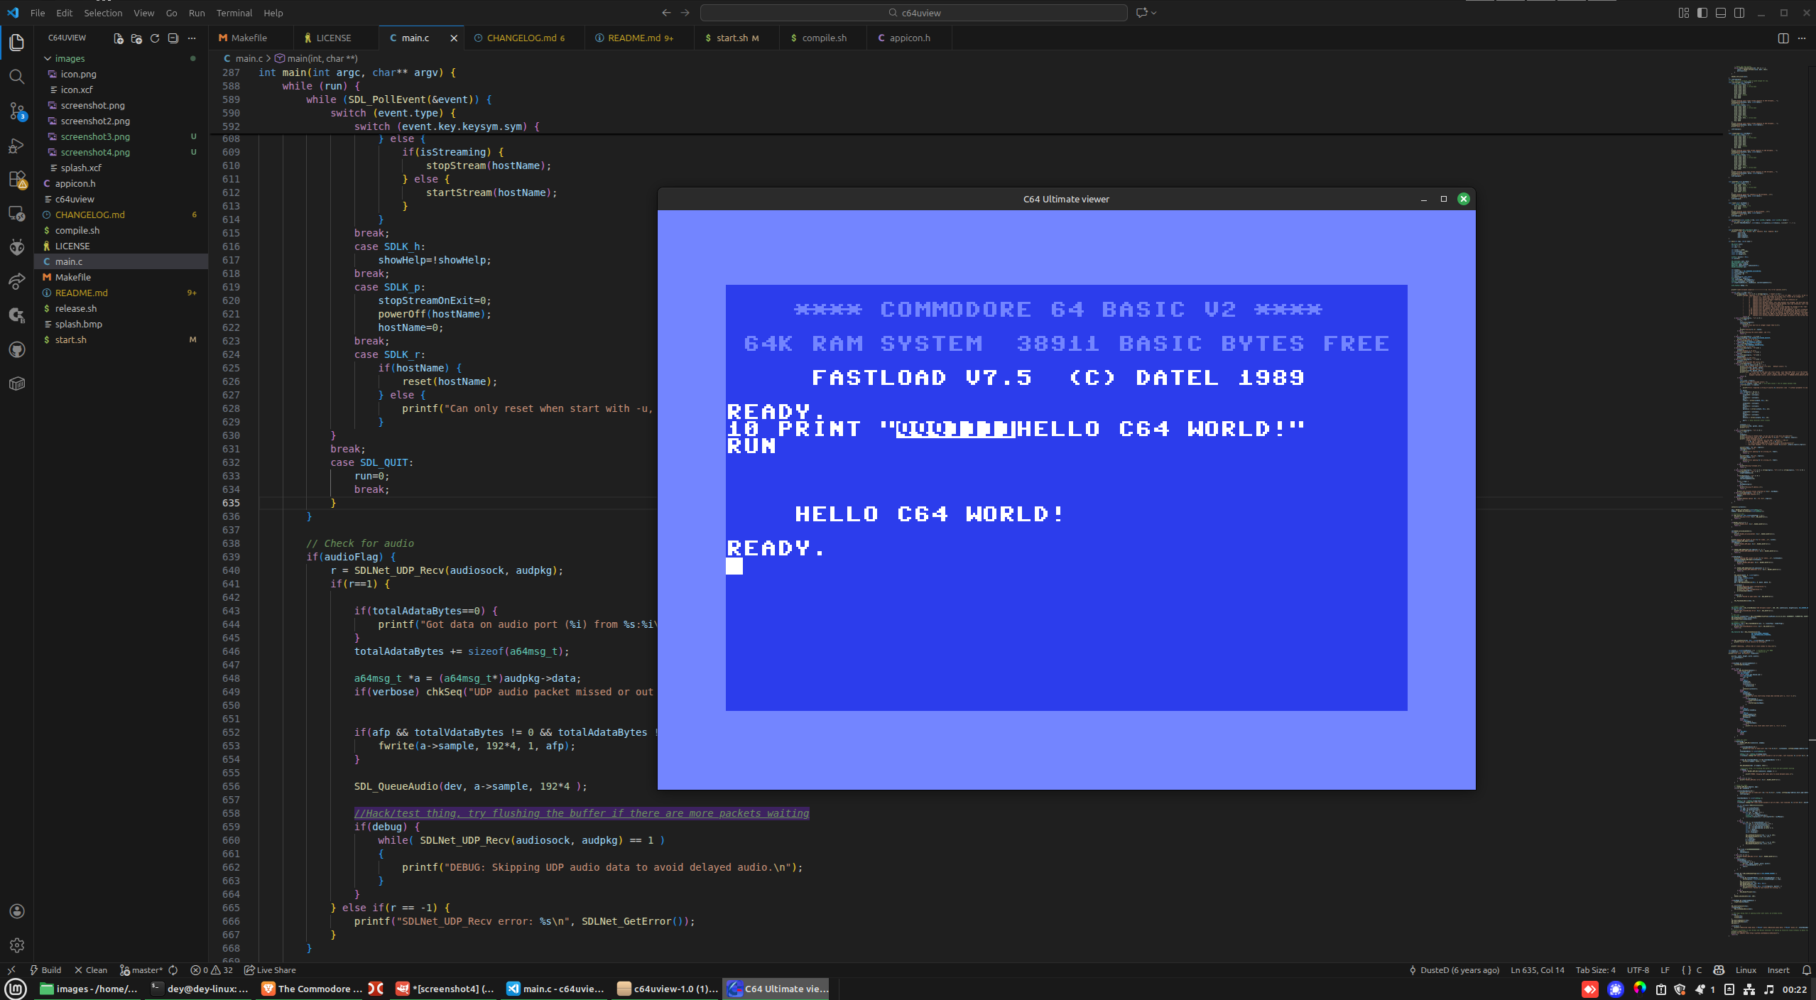
under active development
A simple video & audio stream viewer designed for the new C64 Ultimate owners running Linux systems. Watch your C64 screen output on your computer with real-time streaming.
- Project page
  - https://github.com/Deybacsi/c64uview

Ultimate64 Manager
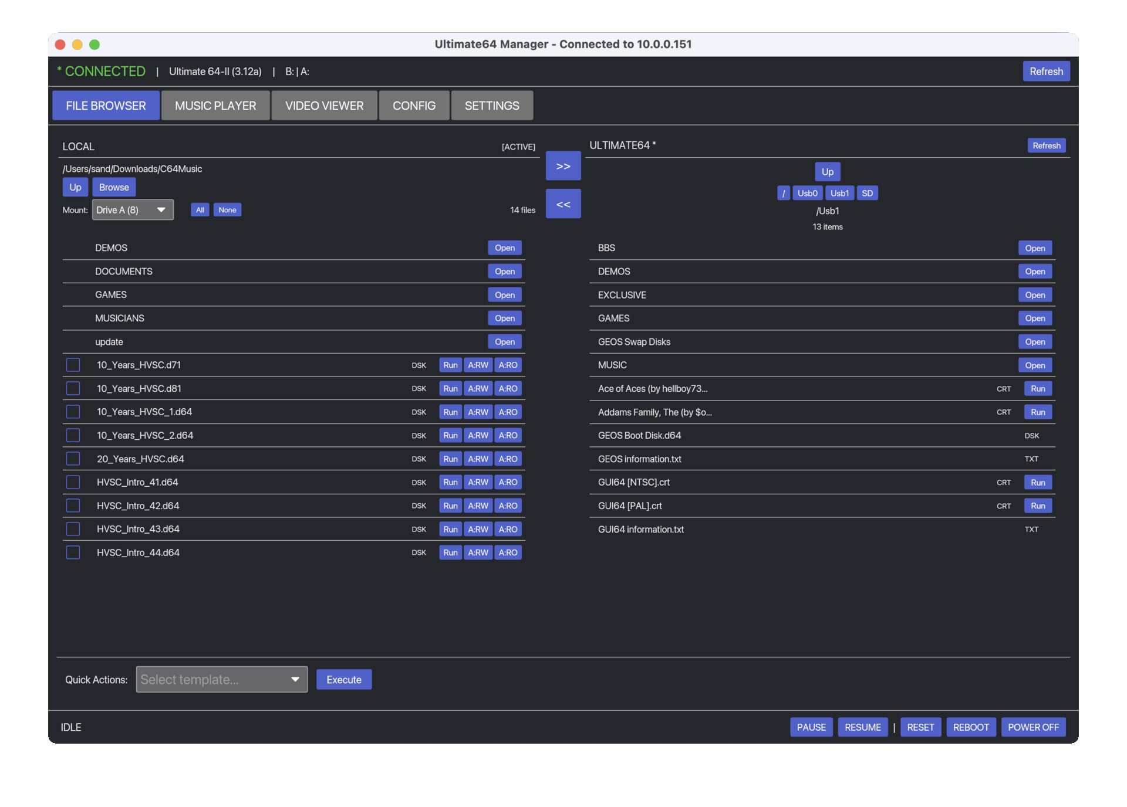
under active development
A cross-platform desktop application for managing Commodore 64 Ultimate, Ultimate 64 Elite and Ultimate-II+ devices. Browse files, stream content, play SID music, mount disk images, and configure device settings.
- Windows / linux / Mac
  - https://github.com/sandlbn/ultimate64-manager
- Amiga OS
  - https://github.com/sandlbn/u64ctl
- iPhone
  - https://apps.apple.com/us/app/u64-ultimate64-controller/id6751809716

U64 Remote
under active development
Remotely send and run a .PRG file on a Commodore 64 Ultimate, (or any 1541u). Mostly that development with CBM prg studio is easier with the Commodore 64 Ultimate, and you don't need to copy files every time.
- Project page
  - https://github.com/AllMeatball/u64-remote

U64 Remote cpp
under active development
Remotely send and run a .PRG file on a Commodore 64 Ultimate. A Linux C++ command-line client for interacting with the Commodore 64 Ultimate over its REST API. This project is a C++ port of the original Go reference implementation and allows remote control and inspection of a C64 Ultimate from a modern Linux system.
- Project page
  - https://github.com/drericflores/c64u-cpp_remote

Commodore C64 Ultimate CLI
A MacOS/Linux/Win command-line interface for controlling the Commodore C64 Ultimate via its REST API.
- Project page
  - https://github.com/cybersorcerer/c64u

Scripts to prepare software for use on the C64U
Tools to prepare data on an other computer before moving it over to the C64U to be used there.

GameBase64 Game Organizer
under active development
A Python utility to organize Commodore 64 games from zip archives into a structured folder hierarchy based on metadata from VERSION.NFO files.
- Project page:
  - https://github.com/jcarr71/gb64-reorganizer

