Finding the right settings

When setting up Wi-Fi how do you pick authentication method?
When setting up Wi-Fi how do you pick authentication method? The arrow keys don’t do anything.
- Solution: the issue is the default color scheme doesn't allow you to see which choice you've selected. If you change default color scheme to “Commodore 1” then you can see which authentication method is selected!

GEOS / REU does not work
There is some doubt of this is actually correct
If you are wanting to use GEOS or any other program that requires the REU, you may need to double check the address for UltiSID 2. Out of the box, UltiSID 2 was at $DF00, which conflicts with the C64U's built-in REU and causes programs to not see the REU. Instead, I move UltiSID 2 to $D420, and it now works flawlessly.
- To get there: C64U Menu → Audio Setup → SID Addressing → UltiSID 2 Address.
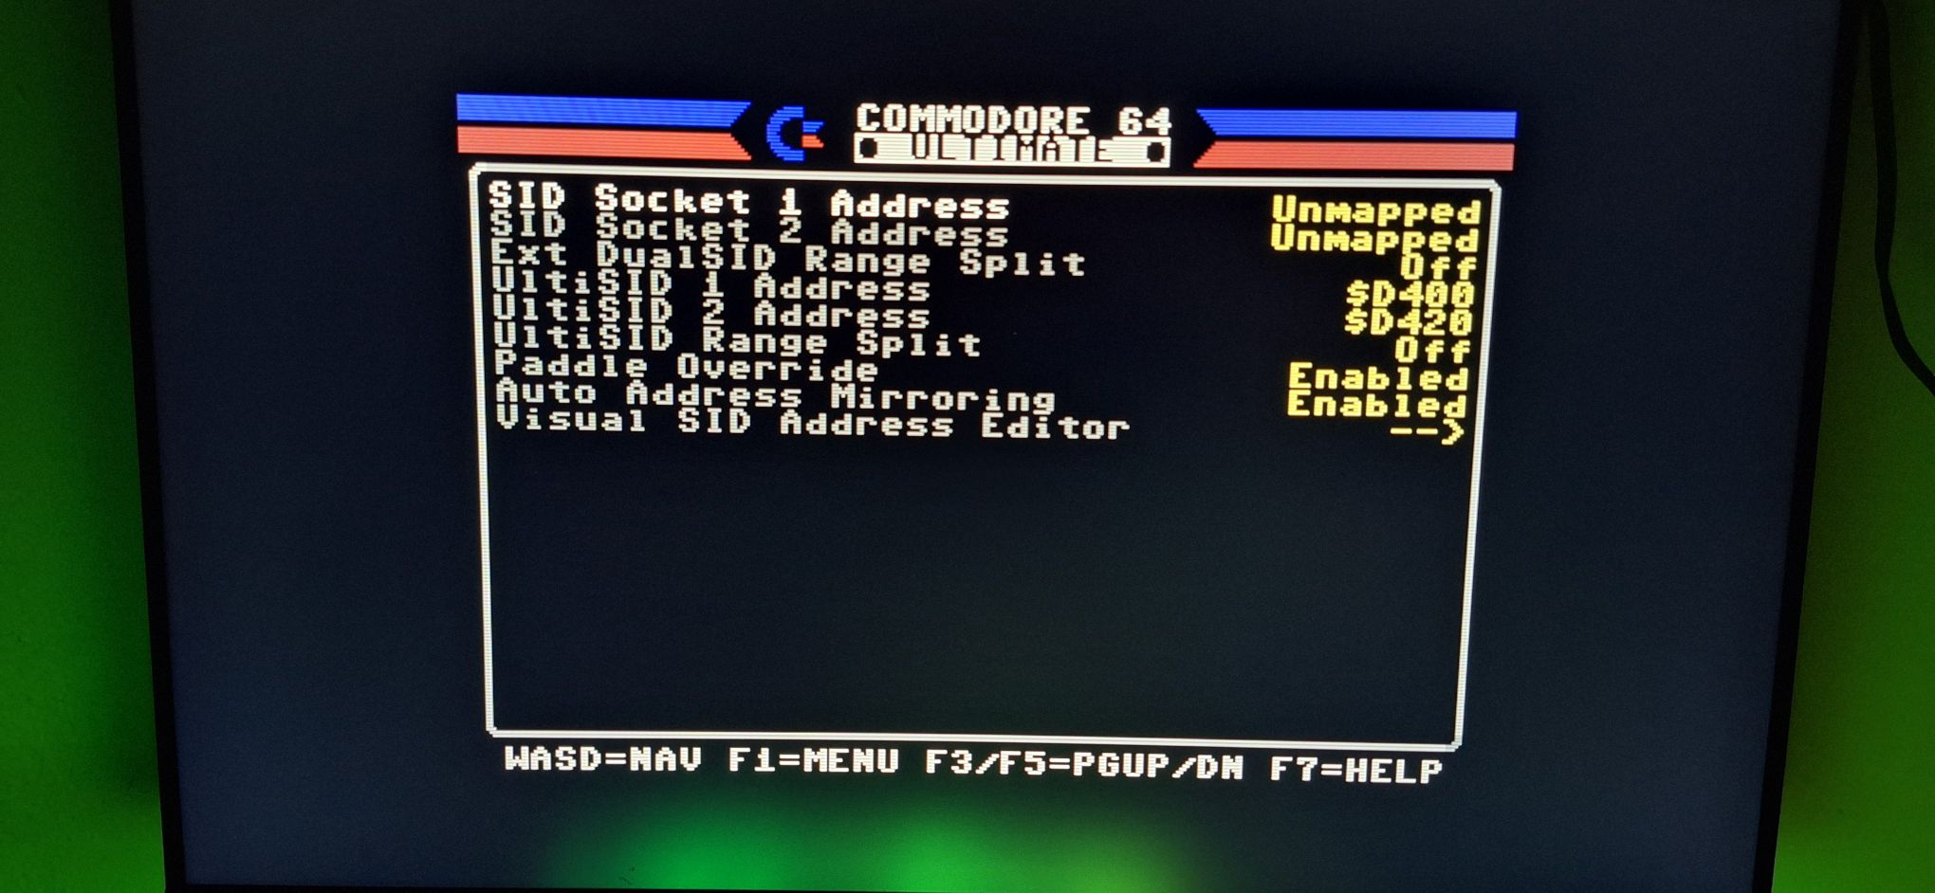

UltimateChat does not work over WiFi
UltimateChat does not work over WiFi. It came on “The Very Second”. It works when connected with Ethernet.
- You are not alone. No known solution at present. (if you know one, please edit)

NTSC 1702 monitor - only setting that works is NTSC-50.
when using my new U64 with a traditional NTSC 1702 monitor, I noticed the only setting that works is NTSC-50. When I attempt to use the traditional/standard NTSC setting, the screen jumps up and down. The 1702 monitor works fine with my vintage NTSC C64.
- Solution: both NTSC-50 and standard NSTC work fine, but I needed to make some manual adjustments via the horizontal and vertical hold on the 1702.

Only left audio channel from 3.5mm jack while A/V jack connected
When an A/V cable with mono audio is connected to a CRT monitor, the 3.5 mm audio output on the Commodore 64 Ultimate only plays the left audio channel. If the A/V cable is unplugged, both left and right channels work normally through the 3.5 mm jack. Some original custom Commodore 64 A/V cables were wired so that AUDIO IN (pin 5) and GROUND (pin 2) are tied together to reduce interference. The Commodore 64 Ultimate, however, repurposes pin 5 as the right audio channel (see User's Guide p.205). When you plug in one of these older-style cables, pin 5 is shorted to ground and silencing the right channel entirely.
- Solution: Use an A/V cable designed specifically for the Commodore 64 Ultimate, or one that does not connect pin 5 to ground. Once the correct cable is used, both audio channels will work normally from the 3.5 mm output.

Dual SID files sound horrible, or only one channel can be heard
Make sure that you have the following settings in Audio Settings → SID addressing:
- SID 1 : Unmapped
- SID 2 : Unmapped
- UltiSID 1 Address: $D400
- UltiSID 2 Address: $D420
- Auto address mirroring: Disabled
The options that were NOT mentioned do not affect the ability to play dual/stereo sids.

