INTRODUCTION
Hi, nice to meet you.
My name is Fritigern, or Friti for short.
I have a bit of experience editing wiki pages. I have run and owned 2 wikis in the past, been a sysop at another, and an occasional editor at Wikipedia.
I have been a CBM nut since 1983, got my first C64 in 1990, took a break around 2003 and a C64U owner since May 2026, and using it every day.
When I stumbled upon this wiki, I realized that a lot of info was missing and also that quite a bit can be done to make the place easier to read and navigate, and since this is a wiki, instead of waiting for someone else to do it for me, I waltzed in and got to work.
If you are reading this and you feel that certain info is missing, or you feel that things can be improved, then make yourself an account (if you don't have one yet) and get cracking. Don't be shy. If you make a mistake, it can be fixed. We do not bite.

“Programmers don't byte, they nybble a bit”
The owner of this website assumes no responsibility for the unhinged ramblings of this user.

FRITI'S PLAYGROUND
* Sub page for testing and stuff
Pics and text.
Let's see what each linking type does….
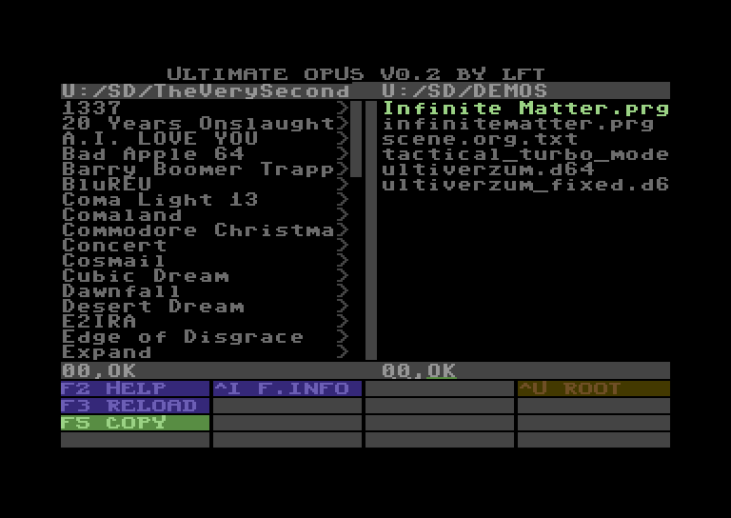
image:u64_screenshot_1784150683.png

