START GDOS64 IN SECONDS WITH FASTBOOT
These instructions are based on a translation of GDOS64FastBoot.pdf (German).

What is GDOS64 FastBoot?
It's a program that loads and installs the GEOS Kernal from RAM (REU or GeoRaM), and continues the boot process from a RAMDisk, thus significantly speeding up the startup process.
PROS:
- It performs a complete restart, including all the autostart programs.
- You can entirely forego external drives on the serial bus. All you need to do is load and run a file from the internal storage medium (SD/USB).
CONS:
- You need to install and configure the system once.
- Any unsaved changes to the RAM BootDisk will be lost unless the contents are saved as a RAM image.

Preparations
It is assumed that you already have a working installation of GDOS64. If you do not, either create one, or wait until a FastBoot install how-to is written that includes installing GDOS64.
Values in RED are suggested. They can be changed to your personal needs or preferences.
- Open the Ultimate Menu
- Enable RAM Expansion Unit, and set its size to 16 MB (no less than 512kb!)
- Open Advanced menu (F2) → SoftIEC Drive Settings
  - Enable IEC Drive
  - Set the Soft Drive Bus ID to 16
  - Set the Default Path to /SD/SoftIEC/
- Start GDOS64 from your usual drive.

Using an existing installation
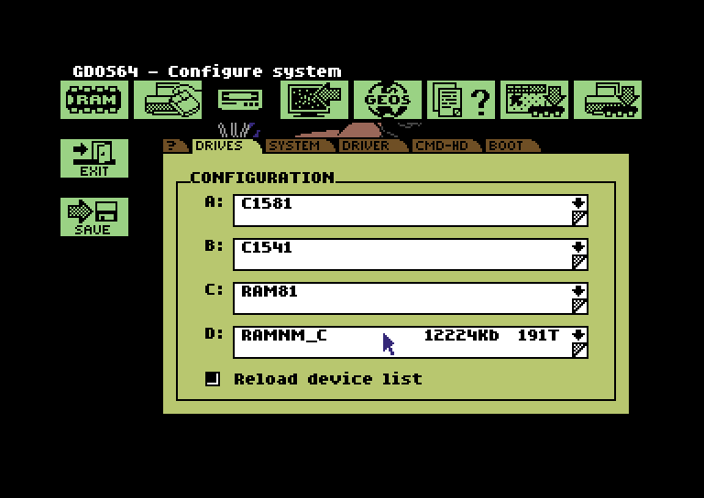
First, start GD.CONFIG and set up a RAMDisk of type RAM1581. Alternatively, you can use a RAMNative drive. (RAMNM_S for SuperCPU, RAMNM_G for GeoRAM, RAMNM_C for a Commodore REU)
This guide uses drive D, since most older GEOS programs only support drives A and B. This leaves drives A through C free for programs, files, or disk drives. All drives can later optionally be replaced with a RAM disk, and GDOS64 can even be booted entirely without disk drives.
Next, at least the GDOS64 system files must be copied from the existing boot disk to the RAM drive. To be able to install future updates for GDOS64, you should ensure that there is sufficient free space on the RAM drive. Alternatively, GDOS64 can also be newly installed on the RAM drive. A full installation is recommended!
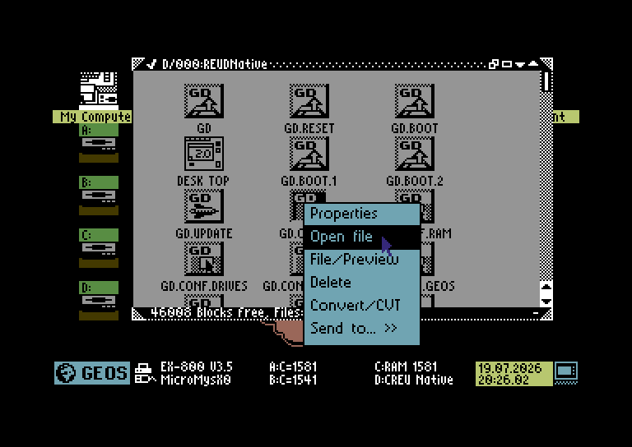
Next, GD.CONFIG should be launched directly from the RAM drive, and the current settings should be saved. To successfully do this, GD.CONFIG should NOT be launched using the C= + E shortcut or via the GEOS menu, as this may cause GD.CONFIG to launch from a drive other than the RAM drive. Launch GD.CONFIG directly from the RAM drive to save the current settings. If necessary, you can also adjust other settings here. Optionally, you can also change the disk name for the RAM drive.
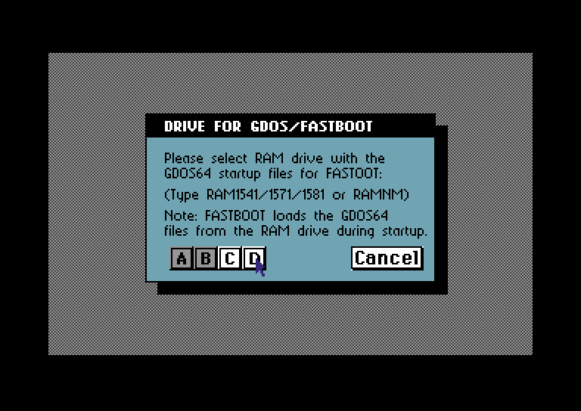
Next, you need to configure the “GD.FBOOT” boot program. To do this, locate the file on the RAM drive and run it. The configuration is saved in the “GD.FBOOT” file itself. Therefore, it is important for the rest of the process to use this file for the next steps!
The startup program is now configured.

Copying GD.FBOOT to SoftIEC
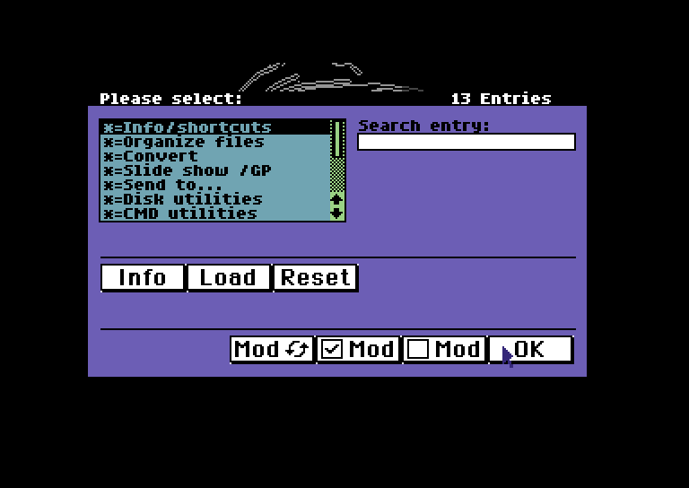
Ensure you have installed the GeoDesk module Disk Utilities and Send To…. To verify, open the GEOS menu and choose Settings → Edit GeoDesk modules. Installed and active modules have *= in front of their names. If necessary, enable Disk Utilities and Send To….
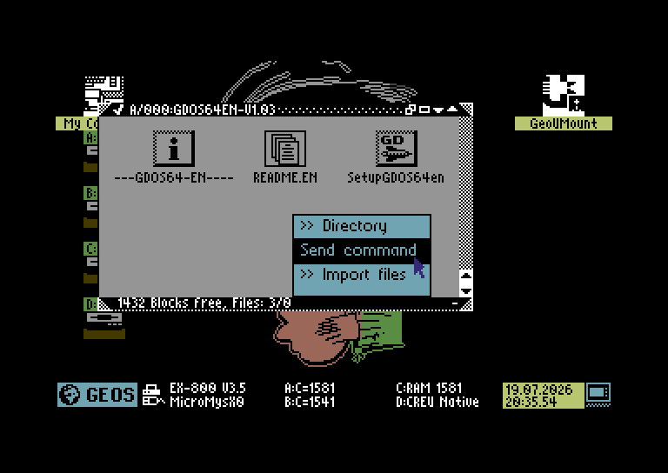
Verify that you are in the correct directory using “Send Command.” To do this, hold down the C= key and right-click in any drive window.
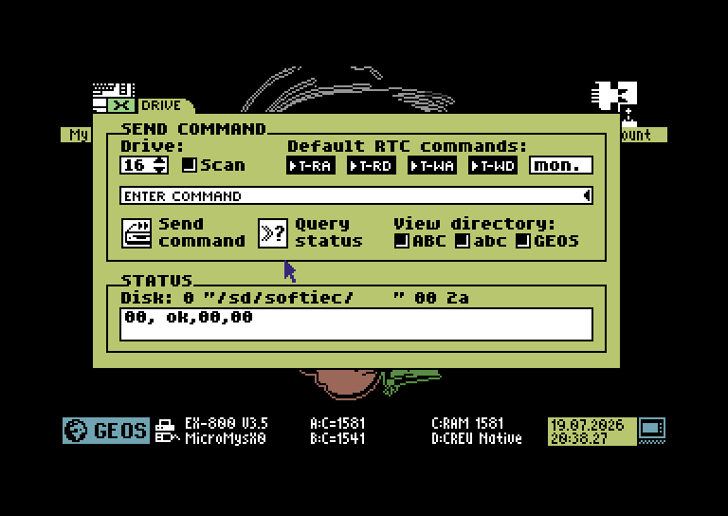
In the “Send command” window that now opens, change the drive to 16. Do not change the other settings. The button »? Query status will show what the current directory is, and also shows the drive's status (should be 00, OK,00,00). Change into the directory where you wish to keep the GDOS64 Fastboot files (suggested: /SD/SoftIEC/GDOS64/). The format of changing directories is as follows:
cd:/SD/dirname
cd:dirname
cd:..
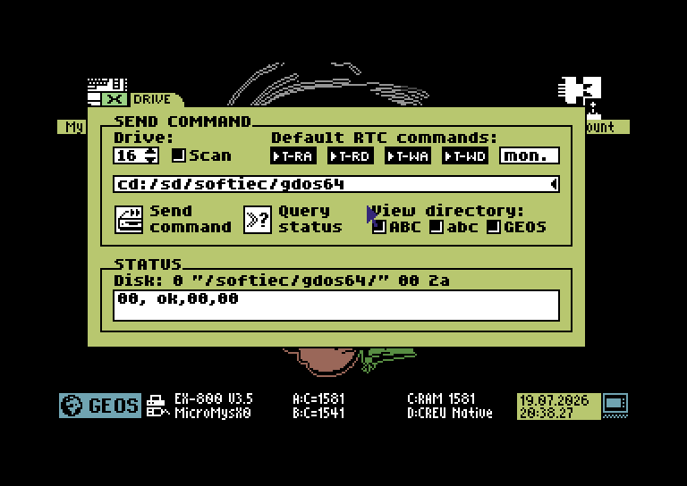
Assuming you wish FastBoot to be in /SD/SoftIEC/GDOS64/, find the text box with “Enter command” and in it, type cd:/SD/SoftIEC/GDOS64/ (can be in lower caps) and press the “Send Command” button. The status line should now read Disk: 0 “/softiec/gdos64/” 00 2a
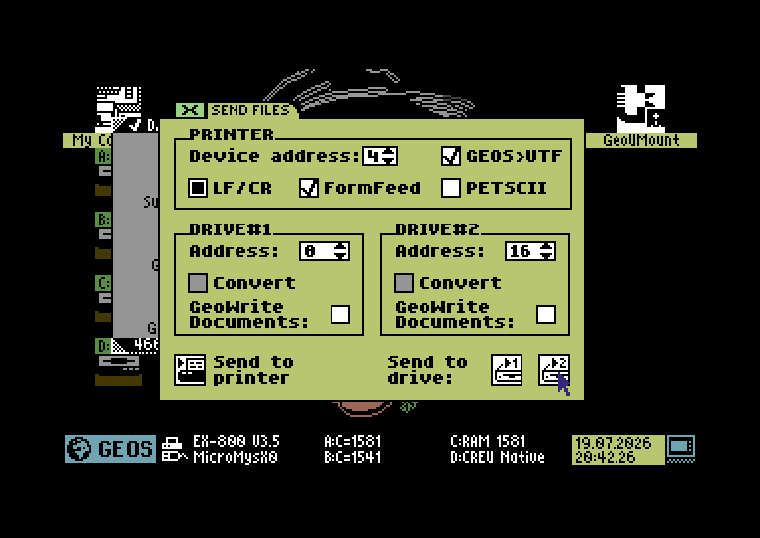
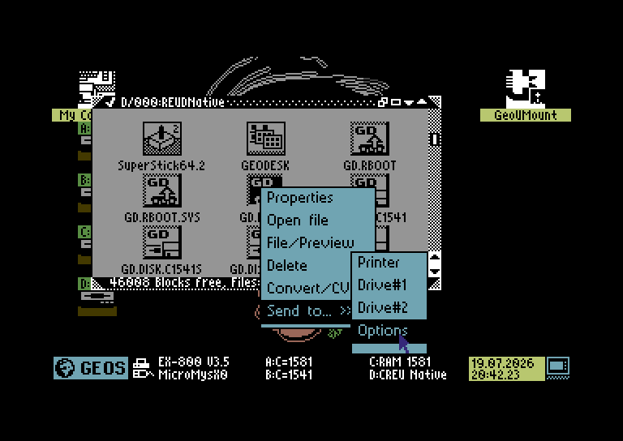
To copy CD.FBOOT to the SoftIEC disk, you now need to right-click GD.FBOOT, and choose Send to… » and then Options. In the window that now opens, change the address of Drive#2 to 16, and click >2 button in the bottom right corner.
You should now exit GDOS64 via the GEOS menu. DO NOT RESET, REBOOT, OR POWER CYCLE THE C64U AT THIS POINT!
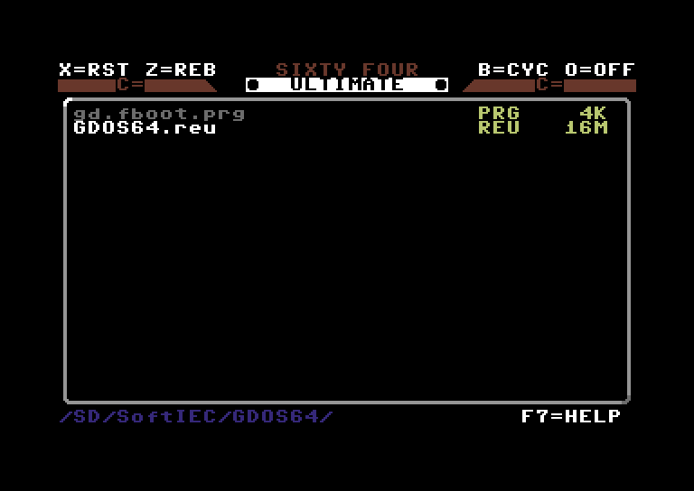
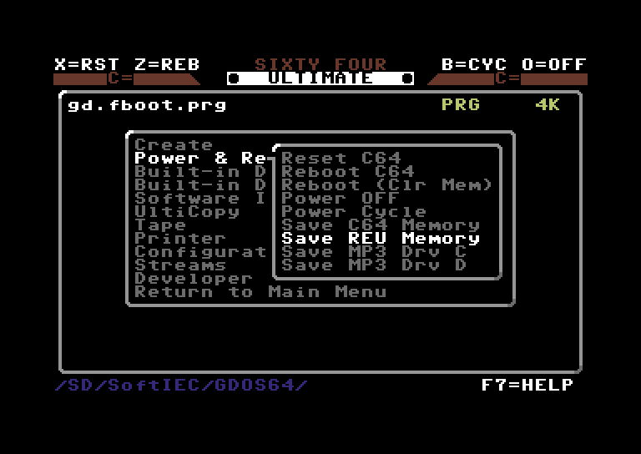
Now open the Ultimate Menu by pulling the rocker switch up, or hit C= + RESTORE. Navigate to where you saved GD.FBOOT, and press F1. Then open Power & Reset and choose Save REU Memory. Choose a file name (I chose GDOS64) and save the file. It is being saved as GDOS64.REU
TIP: Save the current C64U configuration in the GDOS64 folder on your SoftIEC drive. To do this, open the Ultimate Menu, navigate to inside your GDOS64 folder, hit F1 and choose Configuration. Choose “Save to File” and choose a filename. You can now load this configuration before you load GDOS64. Useful when you like to change drive types a lot, or change other config options.
If you wish, you can now power cycle your C64U.

Starting GDOS64 with FastBoot
- If you have saved your configuration, load that config file first.
- Next, load the REU file.
- Finally, run gd.fboot.prg and watch GDOS64 load in seconds.

Updating a GDOS64-FastBoot RAM image
Every now and then, a new GDOS64 version comes out, bringing new fixes and features with it. You will probably want to update your existing installation in order to make use of these fixes and features. In order to do this, you will first have to download the update and save it to a disk image or a RAMDisk. Next, run the installer and choose to update the installation. After the installation is complete, you will need to save the REU image again. You can overwrite the old version, but if you want to be safe, rename the old REU image to GDOS64.reu.old and save the new image as GDOS64.reu

