Buying options

Editions
There are 3 editions.

Basic
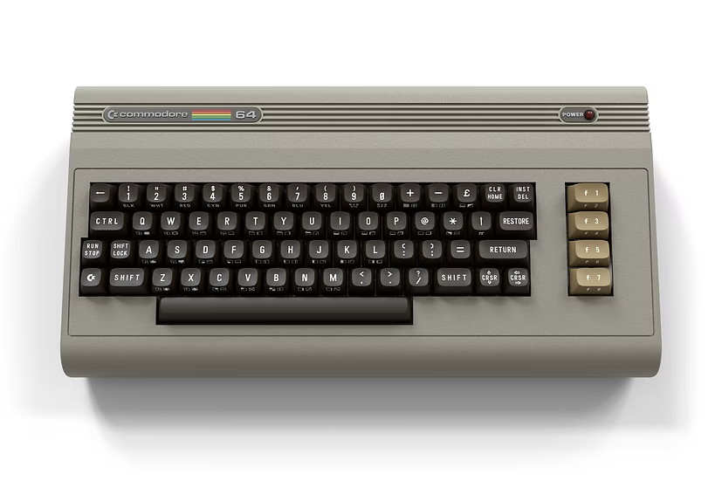
The 'Basic beige' version with the classic look. This is also the most affordable version. USD$350

Starlight
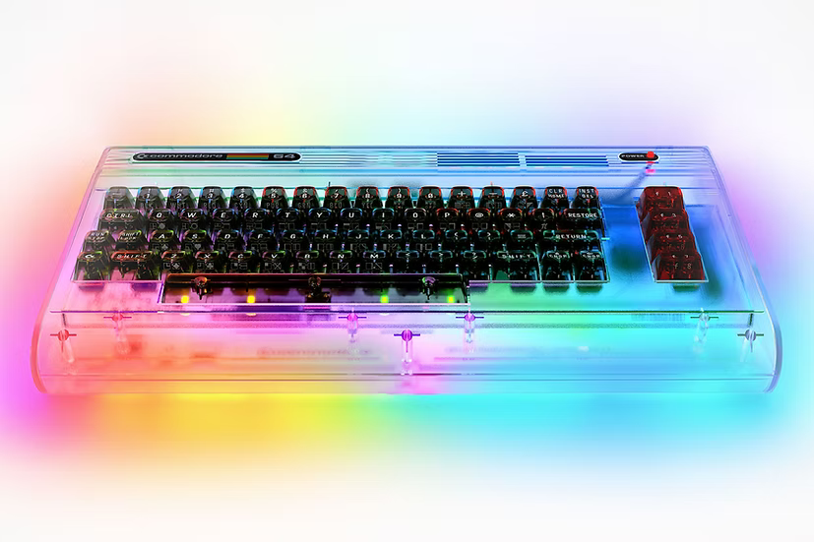
The 'Starlight Edition'. It has a transparent case and PCB with built in LED-lights with software control options for those lights. It is mid priced. USD$400

Founders
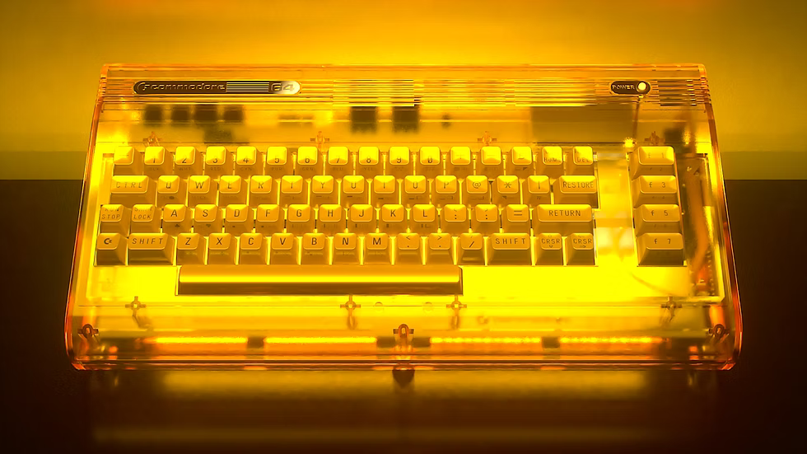
The 'Founders edition'. It also has a transparant case and PCB with built in LED-lights. But it has a distinctive gold-yellow colour and a golden coloured keyboard. This is the most expensive version. USD$550

The difference between editions
Besides the esthetics and the LED-lights are all Commodore 64 Ultimate editions exactly the same from a technical point of view and included materials.
To obtain the transparent effect of the Starlight and Founders editions, lighter materials are used for the construction. This makes the device less sturdy then the basic beige edition. Some buyers have reported their device flexes a lot when pressing the keyboard. Other buyers say it is present but acceptable. see does_it_bend_or_flexes
Flexing may be the result of incorrect assembly and can be significantly reduced by correcting any such issues, if present.
Third-party 3D-printed braces are also available to increase structural strength if additional reinforcement is deemed necessary.
Note: listed prices are without value added tax, shipping and potential import tax. Depending of the destination the final price can differ significantly. When ordering you get a better idea of the final price.

How to buy
The only place to buy them at present is via the website of Commodore:
- https://www.commodore.net/category/computers ⇐ Buy Commodore 64 Ultimate
If you use this referral link you get $10 off.
- www.commodore.net/referral/wztYNJLk8qln ⇐ Get $10 off a sale on the Commodore store

Sales figures
Some very nice statistics about the sale of the Commodore 64 Ultimate
- https://slapsoft.com/c64_sales.html

