Bulletin Board System (BBS)
C64C128The C64U has the capability to host and connect to a wp>bulletin board system. This is an online service that is mostly forgotten and predates the internet. Many bulletin board systems include a message board, real-time IRC-like chat capabilities, online games, and a file repository.
The only thing you can do online with this computer is to connect to a BBS, as the C64U lacks the ability to browse webpages, connect to other FTP servers, download torrents, or anything else associated with today's online services.
The BBS software is included in the 'The Very Second' software bundle.
If you want to connect to a BBS on other devices you need a client;
- MuffinTerm for MacOS and iOS
  - https://muffinterm.app/
- SyncTERM for Windows, Linux, OpenBSD, NetBSD, OS X, and FreeBSD
  - https://syncterm.bbsdev.net/
- DCTelnet - A classic Amiga Telnet/BBS client with Zmodem
  - https://github.com/bruno-frederic/dctelnet

C64U specific BBS's

★ C64 Ultimate Club ★
Sysop Nick McLaren.
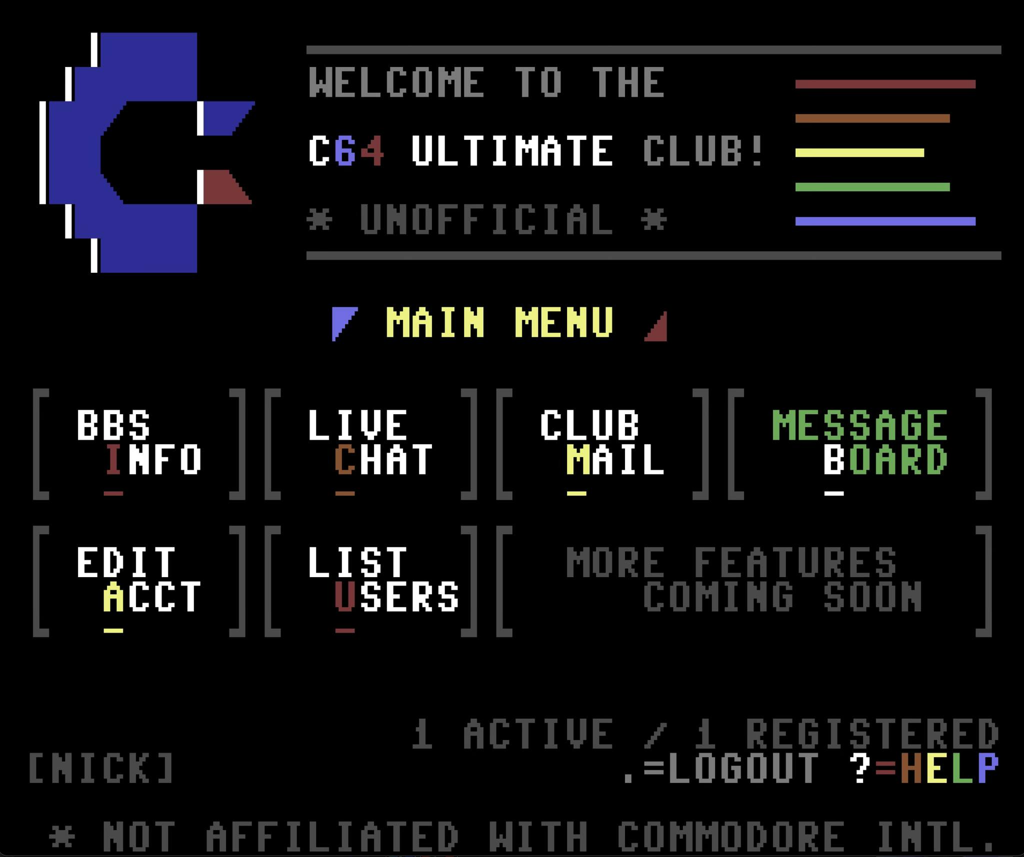C64U Club
- telnet c64u.club (port 6400)
  - use PETSCII, (ASCII is not supported)

BBS C64 Master list
- https://www.commodorebbs.com/

Setting up your own BBS
For those who wish to explore this see the 8-Bit Boyz forum.
Above that page see the menu option 'downloads' ⇒ 'BBS software' section. 'BBS on a Stick' seems to be a good start.

